PHP FRAMEWORK PROJECT

**IDEA OF PROJECT**

The idea is about product booking online from the book store called Bookbuy. Customers can purchase the product online, give their information as address for shipping, name and phone number for identity, then they would receive the product after a specific range of time, gaining by shop system.

The booking system allows customers to select which product (product here is book and photobook) to order, the quantity and both individual and total price. After filling personal information, they would also receive the confirmation from the system and feedback section to rate the product and service.

With the admin account (username: admin, password: admin), the administrator has a right to access to edit, delete and see all the information of the product table.

**DATABASE**

There are book, customer, order detail, order and feedback tables.

|  |  |
| --- | --- |
| Book table | • ID of products  • Name of product  • Price  • Description  • Images |
| Customer | • ID  • Name  • Email  • Address  • Phone number |
| Order | • ID of products / food  • Name of the food  • Customerid |
| Order detail | • OrderID  • ProductID  • Quantity  • Price |
| Feedback | • ID  • Content  • Customer Email  • Category (here choosing product or service to give feedback)  • Rate (from 1 – 5) |
| Login | • ID  • Username  • Password |

**DATABASE CODE**

|  |  |
| --- | --- |
| **login** | CREATE TABLE `login` (  `id` tinyint(4) NOT NULL AUTO_INCREMENT,  `username` varchar(10) NOT NULL,  `password` varchar(100) NOT NULL,  PRIMARY KEY (`id`) ) ENGINE=InnoDB AUTO_INCREMENT=2 DEFAULT CHARSET=utf8 |
| **book** | CREATE TABLE `book` (  `id` int(100) NOT NULL,  `bname` text NOT NULL,  `price` float NOT NULL,  `description` varchar(250) NOT NULL,  `image` varchar(250) NOT NULL ) ENGINE=InnoDB DEFAULT CHARSET=utf8 |
| **customers** | CREATE TABLE `customers` (  `id` int(11) NOT NULL AUTO_INCREMENT,  `name` varchar(20) COLLATE latin1_general_ci NOT NULL,  `email` varchar(80) COLLATE latin1_general_ci NOT NULL,  `address` varchar(80) COLLATE latin1_general_ci NOT NULL,  `phone` varchar(20) COLLATE latin1_general_ci NOT NULL,  PRIMARY KEY (`id`) ) ENGINE= InnoDB AUTO_INCREMENT=2 DEFAULT CHARSET=utf8 |
| **feedback** | CREATE TABLE `feedback` (  `id` int(11) NOT NULL AUTO_INCREMENT,  `fcontent` text NOT NULL,  `customeremail` text NOT NULL,  `category` text NOT NULL,  `rate` int(11) NOT NULL,  PRIMARY KEY (`id`) ) ENGINE=InnoDB AUTO_INCREMENT=1 DEFAULT CHARSET=utf8 |
| **orders** | CREATE TABLE `orders` (  `id` int(11) NOT NULL AUTO_INCREMENT,  `date` date NOT NULL,  `customerid` int(11) NOT NULL,  PRIMARY KEY (`id`) ) ENGINE=innoDB AUTO_INCREMENT=2 DEFAULT CHARSET=utf8 |
| **order_detail** | CREATE TABLE `order_detail` (  `orderid` int(11) NOT NULL,  `productid` int(11) NOT NULL,  `quantity` int(11) NOT NULL,  `price` float NOT NULL,  PRIMARY KEY (`orderid`) ) ENGINE=innoDB DEFAULT CHARSET=utf8 |

**HOW IT WORK**

CUSTOMER SIDE

# Main page

There is the navigation menu bar in the top of the page and the link to find out this document below.

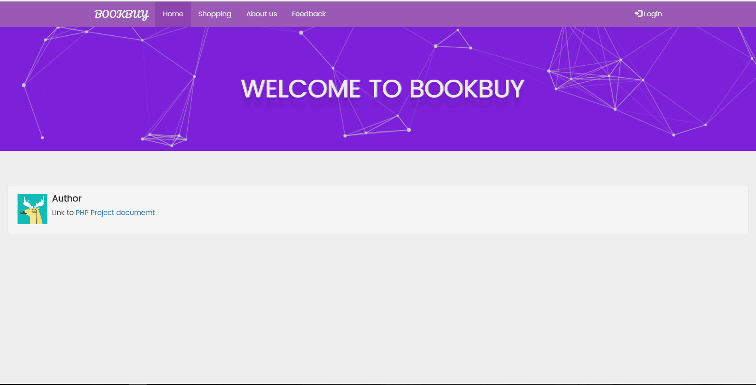

# Shopping page

This page show list of product and shopping cart. Click the ‘add to cart’ button to add the product into shopping cart. The product list comes from the ‘Book table’ in database, and the shopping cart comes from the libraries cart in codeIgniter. According to CodeIgniter, the shopping cart permits items to be added to a session that stays active while a user is browsing my site. These items can be retrieved and displayed in a standard “shopping cart” format, allowing the user to update the quantity or remove items from the cart.

For example, when you click on “Add to cart” button: DOOM DADA book, the line “There is no item in cart” in the shopping cart area above will disappear, the info of DOOM DADA book will appear instead.

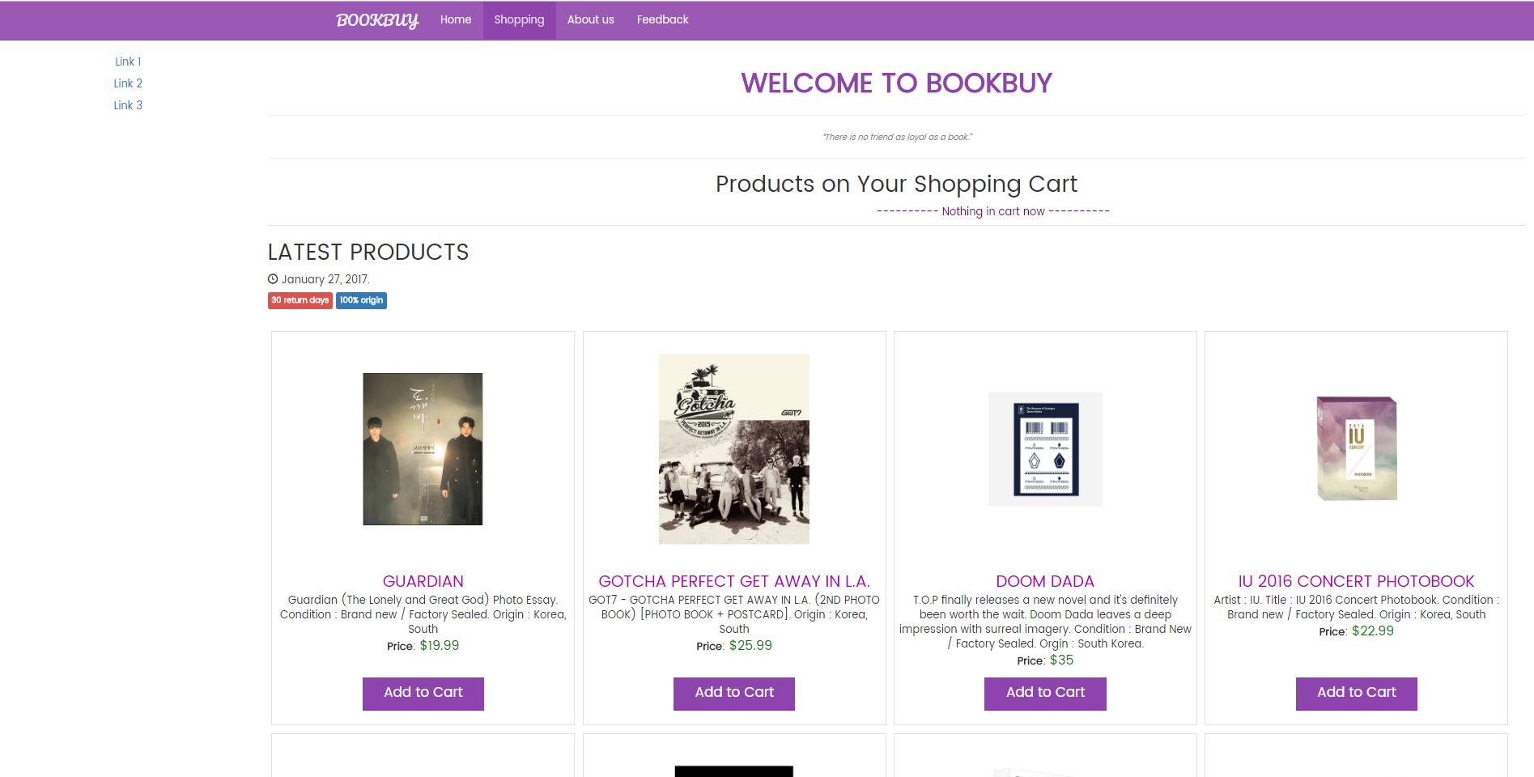

Then client will see the shopping cart has items above. There are also 3 option buttons: clear cart, update and place order. There is also a X cancel button in each row to cancel the product you do not want anymore.

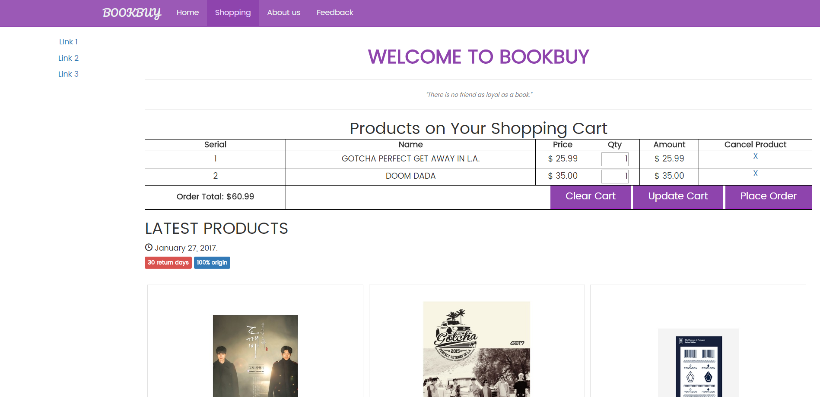

With clear cart button, there will be a confirm modal appear to ask if client is sure to clear all the items in shopping cart.

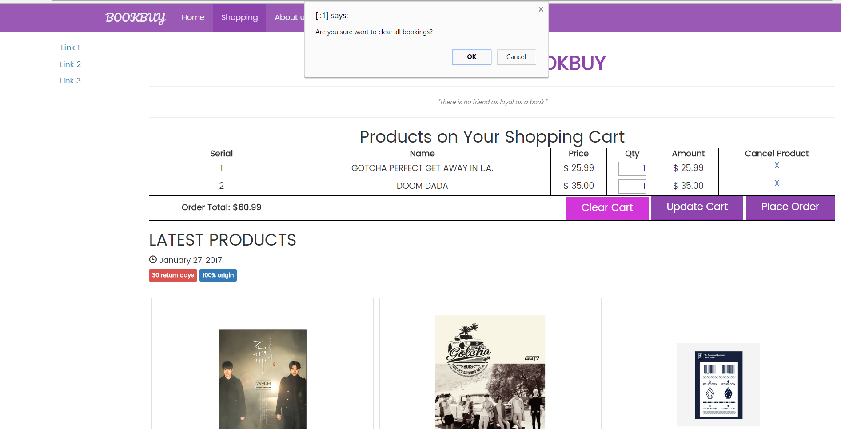

With update button, client can change the quantity, then click the button, it will update the changes also update the amount of price.

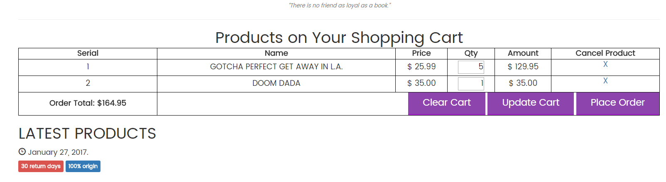

When clicking the place order, it will move to the show_bill page for client see the total amount price and fill in the personal information.

# Show bill page

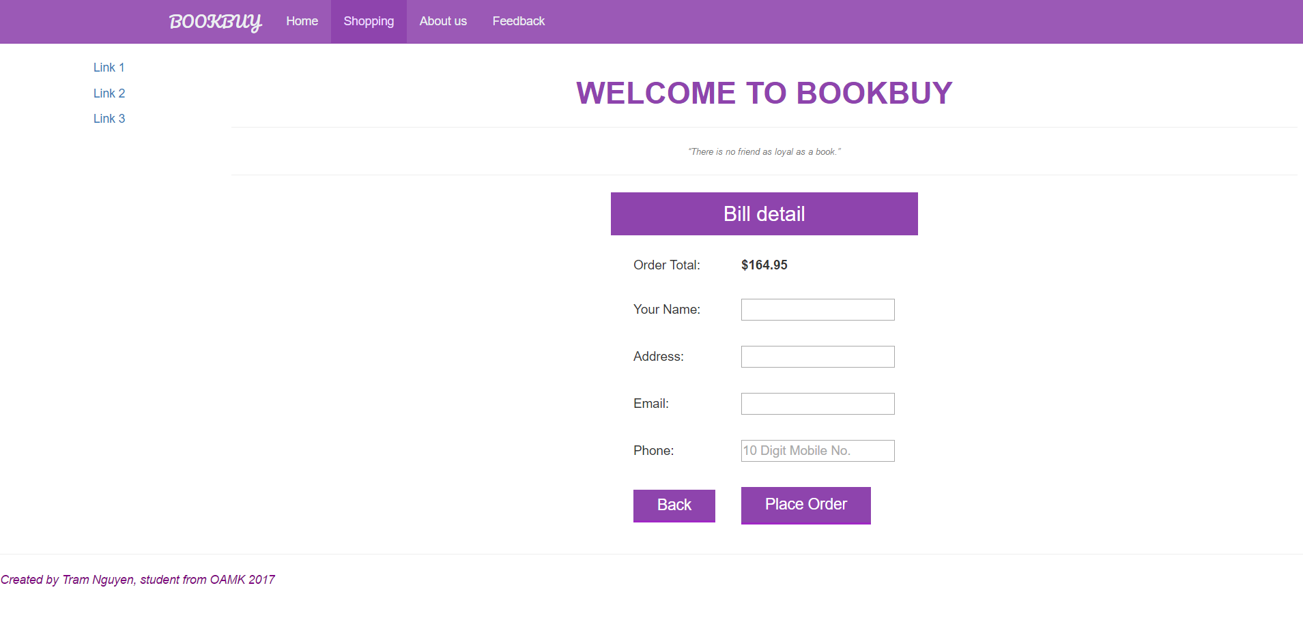

After fill all the information(client have to fill all the field, if not he or she will be asked to fill all or he or she cannot complete the place order step), click the ‘place order’ button to complete the order. Then, the system will show the confirm page to tell the client/customer that their booking order is successful.

# Confirm Page

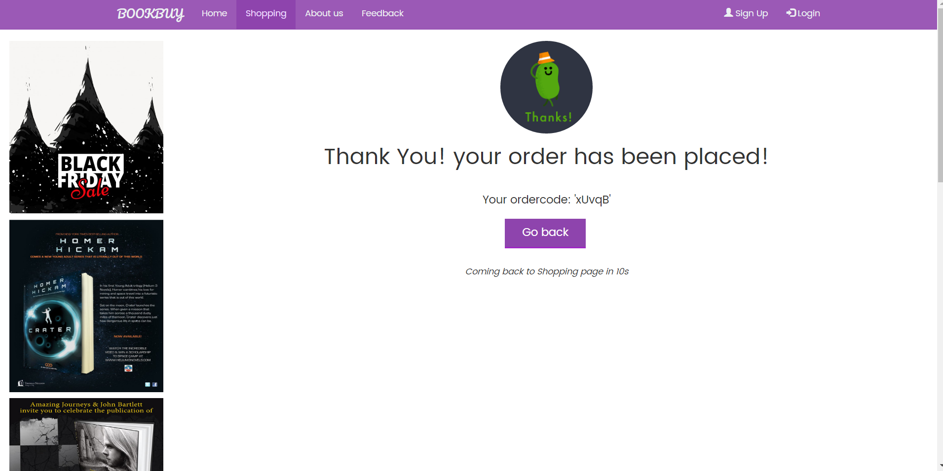

This means the book shop has received the customer’s order, the staff will read and then deliver the product and collect the cash from customer.

(The payment online will be upgraded soon)

The page will automatically go back to shopping page in 10 seconds or client/customer can click the button ‘go back’.

# Feedback Page

The feedback page can access in the navigation menu on the top. Here, client/customer can give their feedback about the product or the service by fill in their email, choose between ‘service’ and ‘product’, give a rate from 1-5, then their feedback content. For example, I give the feedback for the product called Guardian, then clicking the ‘leave feedback’ button, my comment will be displayed in the product side. Service feedback will be the same.

All the feedbacks will be stored in the feedback table in database and shown in the feedback page.

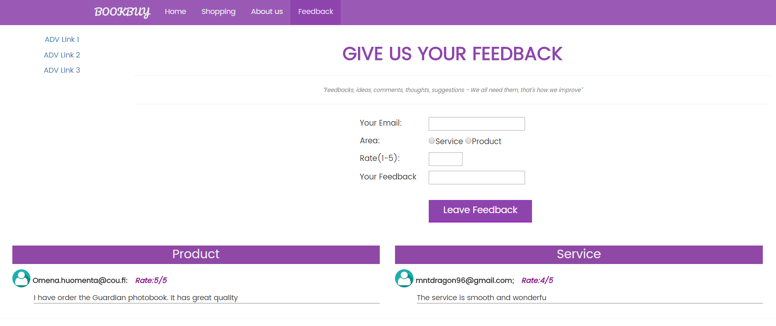

Admin

In the admin side, you can display all the list of product from the book table in database, also add and delete the product with the admin account.

ADMIN: username: admin, password: admin.

By clicking the log in button in the right of top navigation menu in main page, you can go to the login page, here filling the username and password of admin. If both username and password is right, you can access to the ‘show product’ page where displays the list of product information loading from the book table in database.

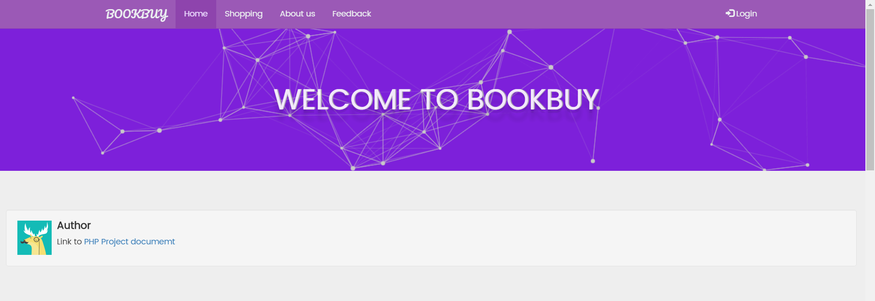

# Login page

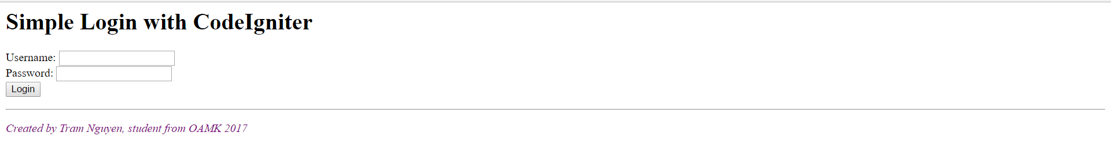

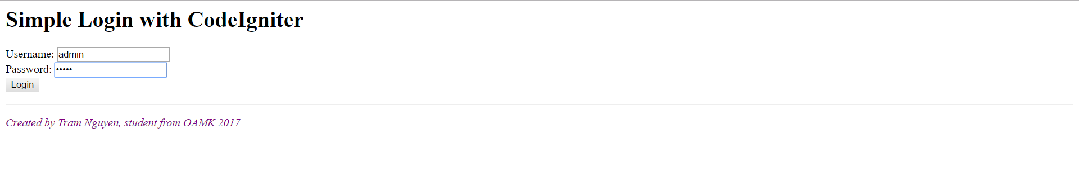

# Show product page

The navigation menu on top change content to home, show books(product), add book and delete book.

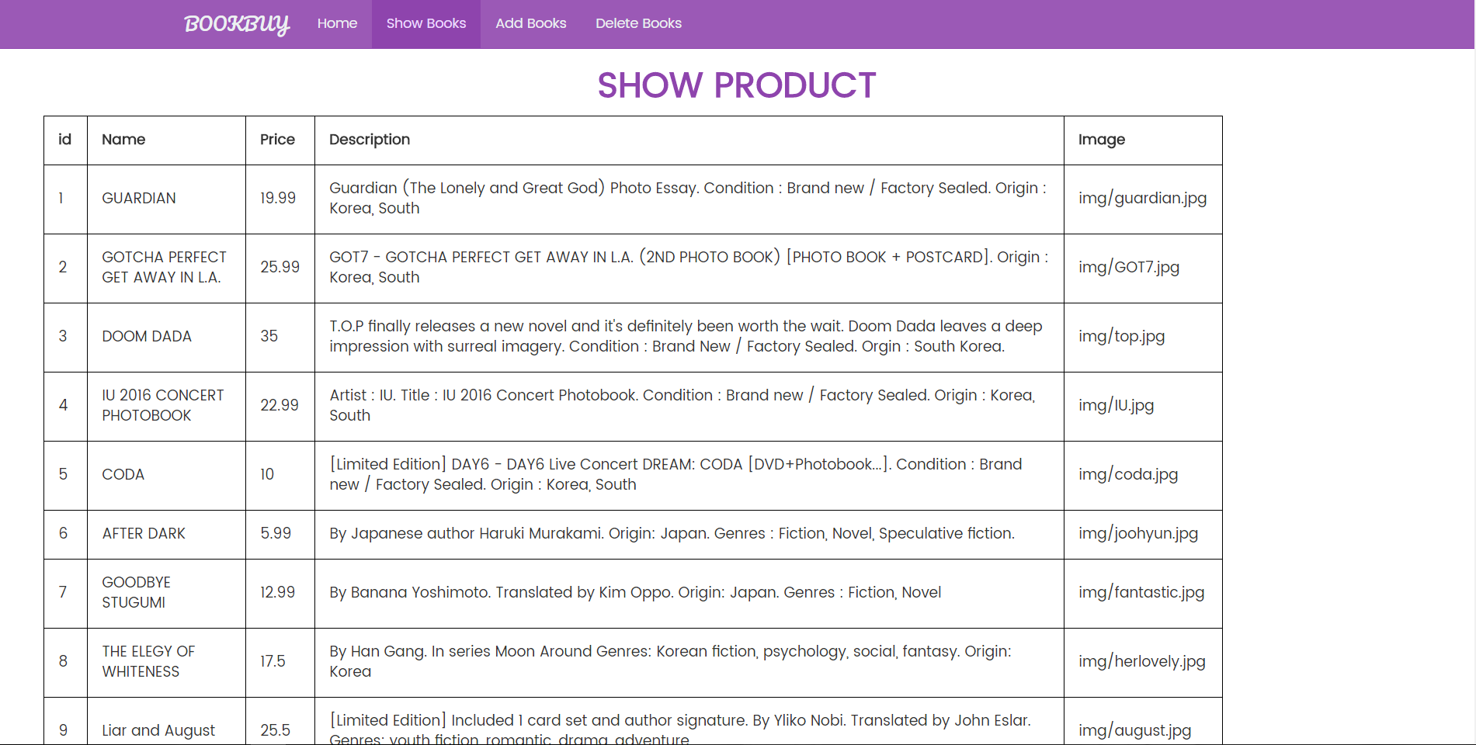

# Add Book page

In ad book page, admin can add new product by fill all the field in the table below, then click save, the new product will be saved in the book table in database. This new product will also display in the shopping page.

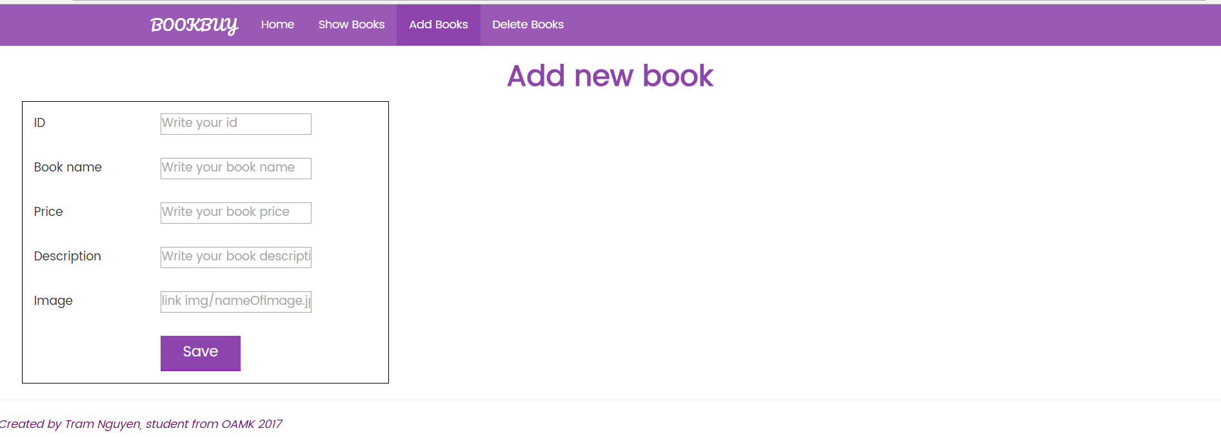

If the add process success, the lien data inserted will appear to let the admin know.

For example, I add a new product named okCat as below.

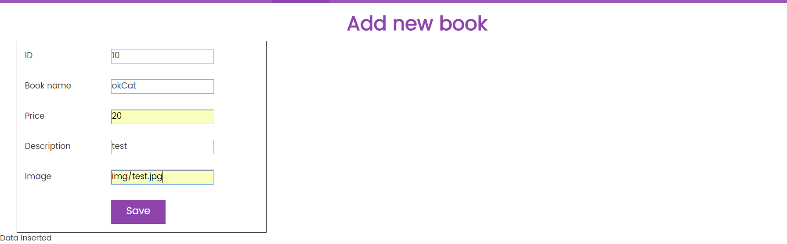

Then we can check in the show book(product) page or shopping page to check if the new product be there.

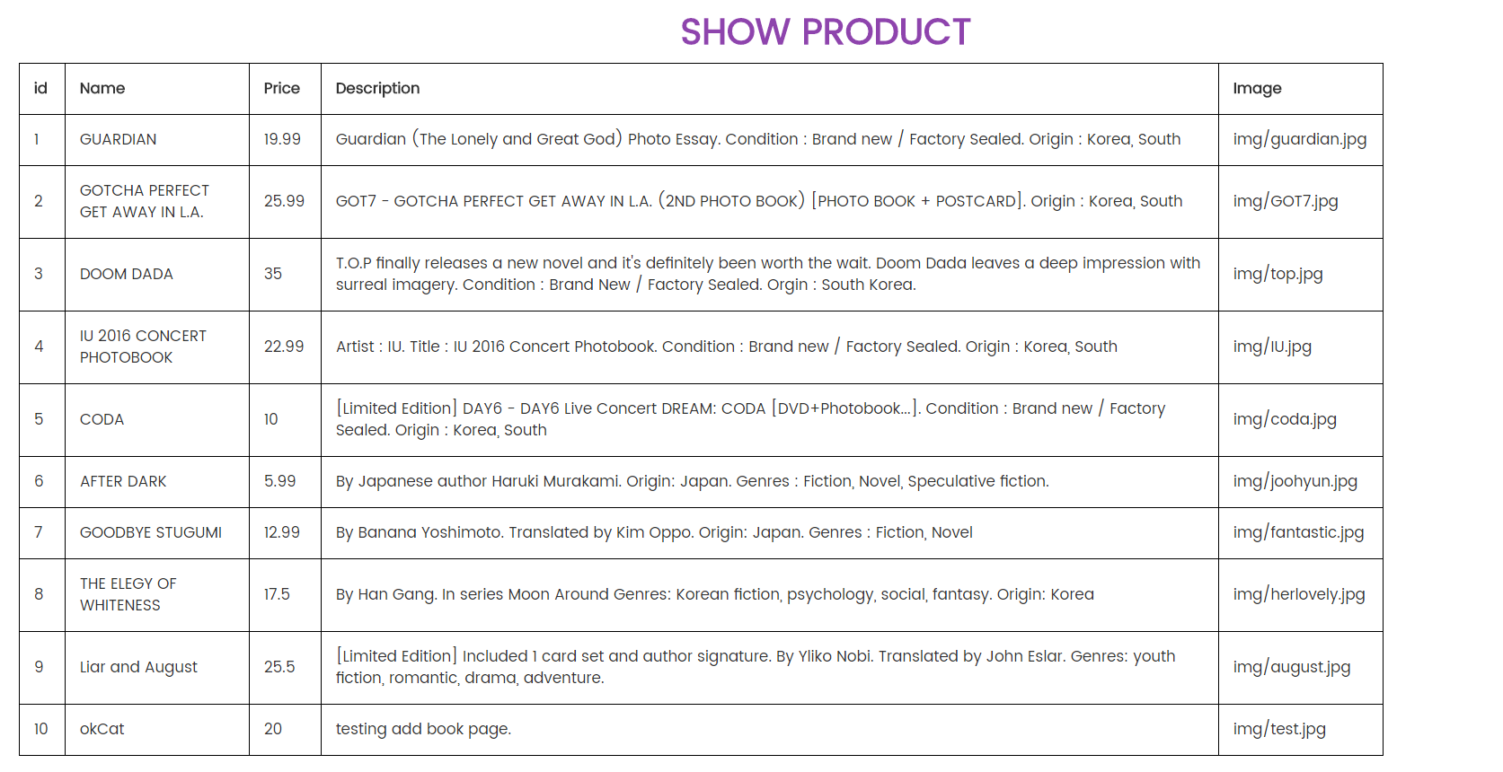

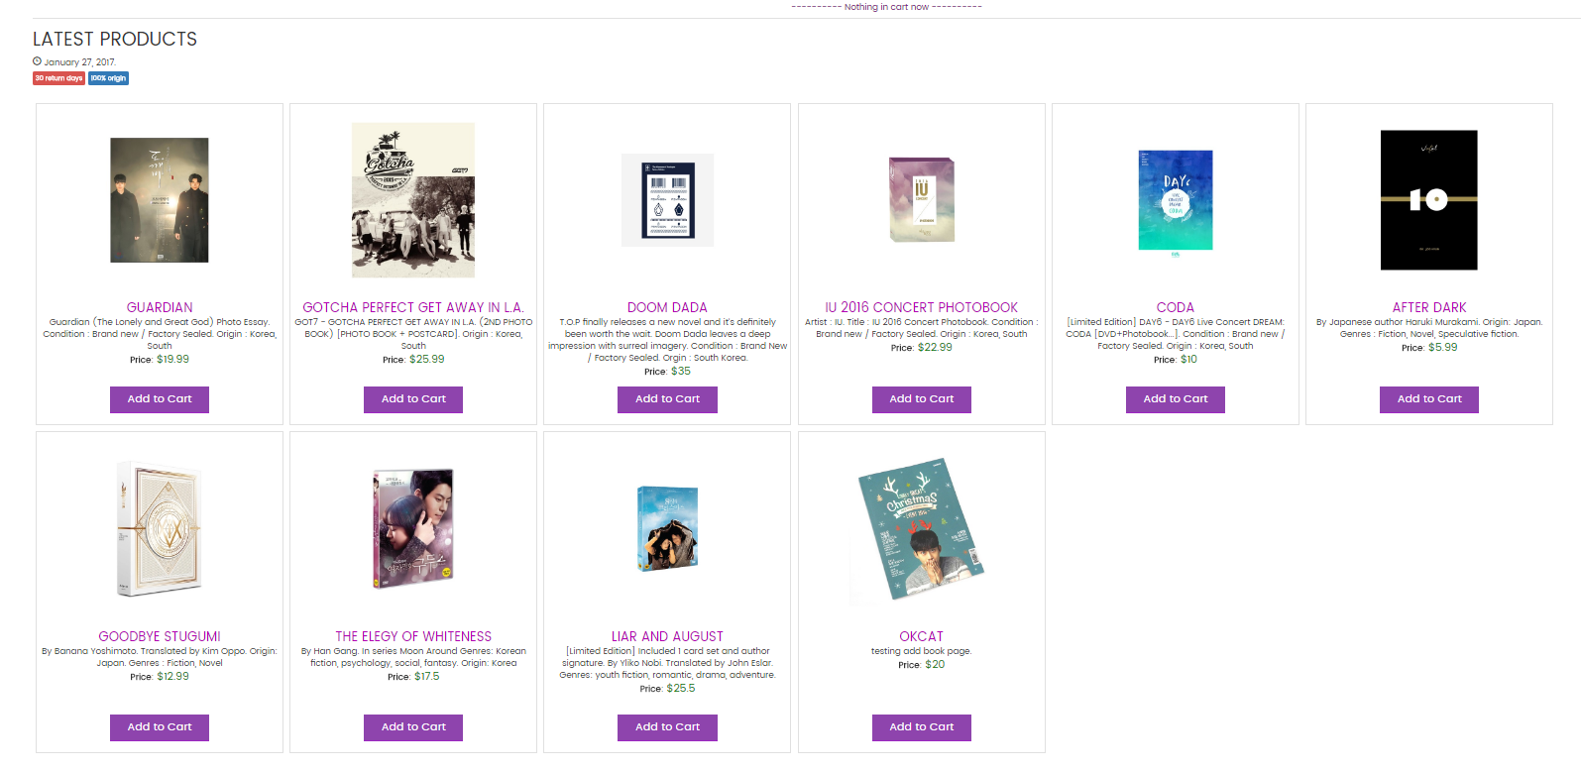

# Delete Book page

There will be delete button in each row of the button to delete product. When clicking the button, it will delete the product in the book table in database.

For example, I delete the product id = 10, named okCat. The row of the deleted product will disappear. I can also check in the show book(product) and shopping page to make sure if it success.

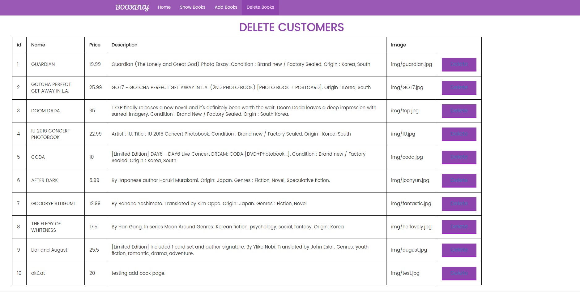

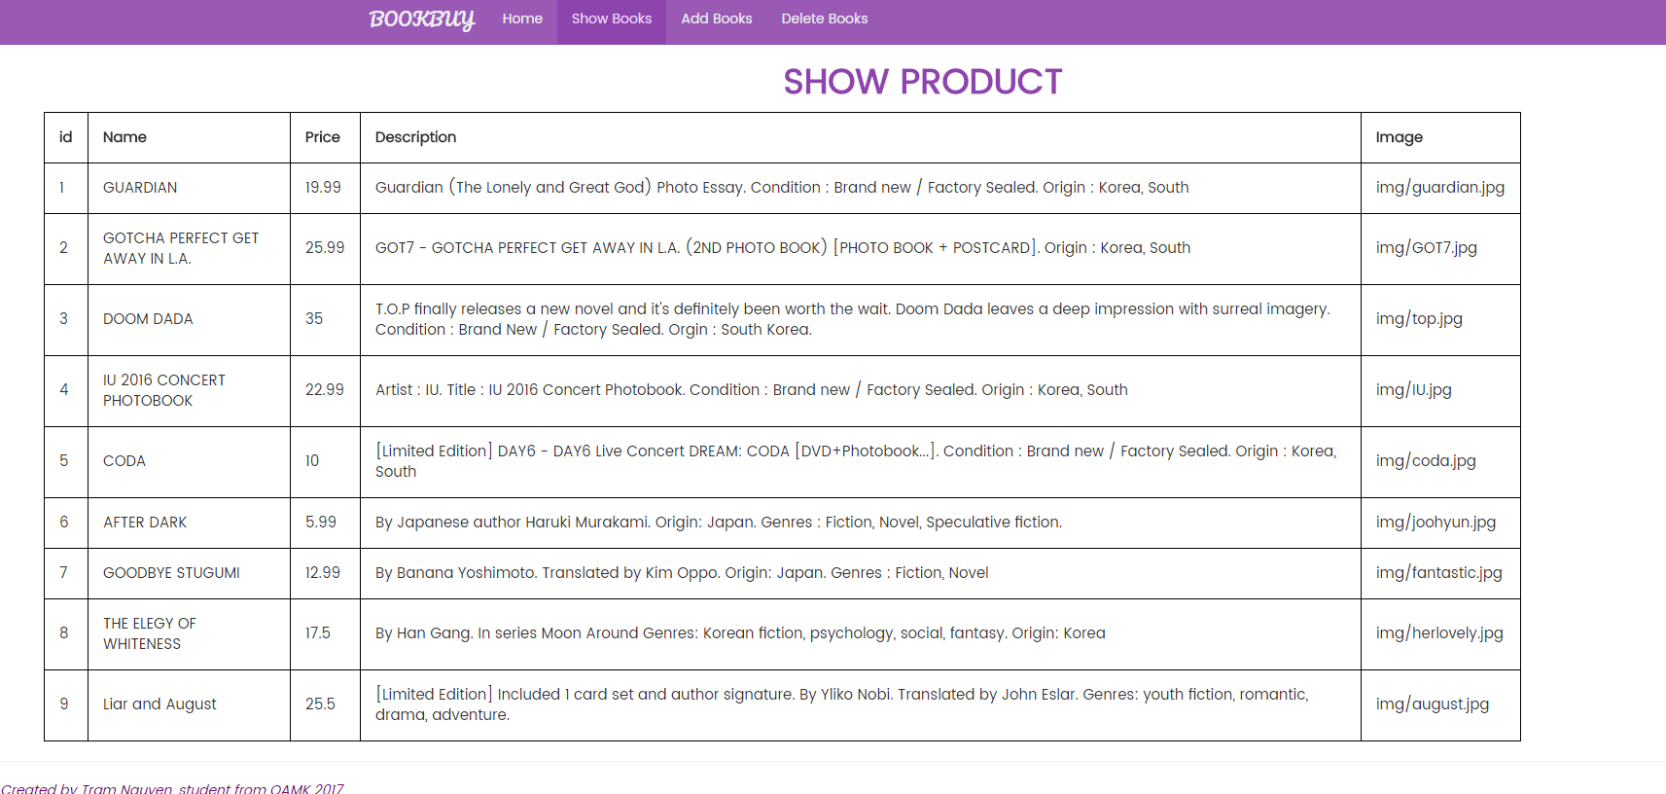

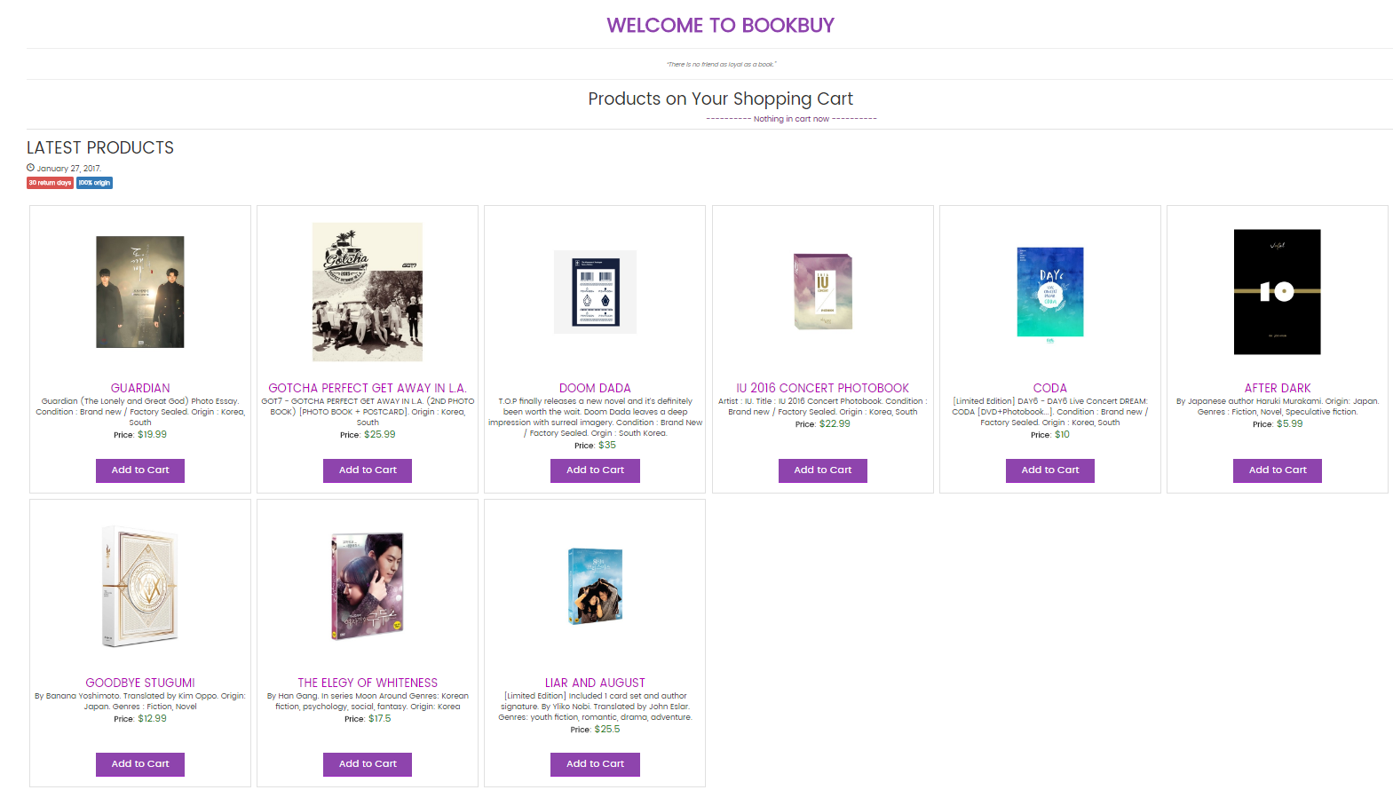

As you can see, the product named okCat has been deleted and disappear on 2 page below.